**Each page in our HTML project will be in its own notepad file, so for example we will have a home.html, myhobbies.html and aboutme.html.**

**We then use navigation bar or navbar to navigate our website.**

**HTML5 makes this even easier with the <nav></nav> tag. Inside the nav tags we create a list of links using the <li></li> for the list elements and the <a></a> tag for the links.**

**The links will have the address of our other pages so when we click on them we should move to the clicked page.**

**So how do we do this?**

**First we need to add the navbar to our page. (The navbar should be on every page to allow navigation from and to each page)**

**So for this we add the following within the <body></body> tags of our page:**

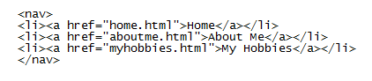

The **href** property in the <a> tag is the **address** of our other files/pages. So first make sure your **all your html files are in the same folder**. Then you can call them by just putting their name into the href property like in the example above.

**When we render our page we should see the following:**

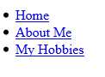

**Now that’s not a very nice looking navbar so how do we style it?**

**Well to style it we’ll use CSS or Cascading Style Sheets. In the coming weeks we’ll go through these in more detail, but for now just know they help us to style the code in our HTML files, add colors, images, change fonts and much more.**

**CSS is added using the <style></style> tags. These tags go in between the <head></head> tags of our page.**

**So in between the <head></head> tags add the following code:**

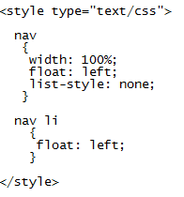

**Now render the page again and we should get the following:**



**So now you have the basics, look up more ways you can use CSS to style your nav bar!**

**And remember BE CREATIVE ☺**

**We target the list by referencing the li tags; the li tags are inside the nav tags in our html so we must reference it by putting the nav selector in front of the li selector.**

We then add a position of float: left, so all the list items position left within the navbar. And that’s why instead of going beneath each other, they float next to each other.

**We target the nav tags by referencing nav like here.**

We then added a width of 100%; a position which is float left so it stays on the left of the page and made list-style: none to get rid of the bullet points which appear with the list tags.

**Ok that’s looking a bit better, but how did we do that?**

**Well within the style tags we use CSS selectors to target the code we want to style.**

